Modern Transit Society
P.O. Box 5582, San Jose CA 95150 408 221-0694

To: City Council, City of Santa Clara
Cc: staff
From: Akos Szoboszlay, President, Modern Transit Society
Agenda Date: July 18, 2006
Agenda Item: Support opening 5 fences and using EXISTING pedestrian paths.
Dear Council Members,
This is requesting support for opening 5 fences to enable using a mostly parallel route to San Tomas, and allowing EXISTING pedestrian paths to be used for portions that are along San Tomas. This is separate from the request to use shoulders. This request was originally on the March agenda of the Bicycle Advisory Committee (BAC), at the same time as the repeal request, but was delayed until now. The BAC vote is attached, on the last page.
The Board of Supervisors ordered creation of pedestrian paths along all expressways for pedestrian use in 1991. County Roads’ staff has stonewalled for 15 years on path creation, using the City’s prohibition as the excuse not to comply, with City staff’s concurrence. If they would have complied, there would be no conflict today!
Benefit to Santa Clara pedestrians — including transit patrons:
- If all 5 fences are opened, that would enable a pleasant route by using 4 relatively short sections of pedestrian paths along San Tomas, between Monroe (“Creek Trail”) and Benton, a distance of 1.2 miles. Two of these fence openings are at bus stops.
- Eliminates a half mile detour using the nearest alternative — Los Padres. It takes about 10 times longer to walk that than to make the same detour with a car. In terms of time, that is the same as forcing a driver into a 5-mile detour for no logical reason. Devaluing time of pedestrians makes them 2nd class citizens.
- Eliminates needless crossings of San Tomas (11 lanes of traffic including left turn lane) and other streets and commercial driveways, thus greatly increasing safety because, by far, most fatalities are crossing fatalities.
- Can immediately start with one fence opening, the one shown in the County Expressway Master Plan with two sidewalks almost touching, but separated by the fence. Other fences can incrementally be opened. The route would use other existing pedestrian paths in the interim or as a substitute if an opening is not viable.
Staff omitted and contradicted documents
Staff had omitted giving important documents to Council in our request to use shoulders, which are also relevant to the current issue, pedestrian paths and fences. This omission enabled County and City staff to contradict both 2003 and 1991 Board policies and the 1991 Board order to create pedestrian paths along all expressways for pedestrian use. Quotes and copies follow.
Quotes (with copies) of violated policies and the Board order:
Use of pedestrian paths and arterial roads by pedestrians is supported by policies of the County, VTA, State and FHWA. These policies are quoted below in one or two sentences each. There are numbered quotes linking to copies of pages from the original documents that are attached.
- 1991 Board Action: Ordered staff to create pedestrian paths on all expressways.
“Approve the proposed new program to provide pedestrian pathway facilities along the expressway system at the annual level of $75,000.”
[See Quote 1 from attached page 2 of August 20, 1991 action]
Our comment: Staff opposed existing path use in violation of this Board action.
- Staff report for that Board Action: “ [The predecessor] Transportation Agency’s position is that
it will take several years [from 1991] to remove all obstacles [basically, “cut back brush”] in the buffer area [between curb and property-line] from the entire expressway system.”
[See Quote 2 from attached page 3.]
Our comment: If they would have complied, there would be no conflict today!
- 1991 Board Policy: “It is the [Board approved] Policy ... to encourage cities to repeal pedestrian prohibition ordinances, except where ... the ... area (between the curb and property line) is impeded by obstacles.”
[See Quote 3 from attached page 2 of 1991 policy.]
Our comment: Staff contradicted this policy because no obstacles exist at 3 blocks (see photos).

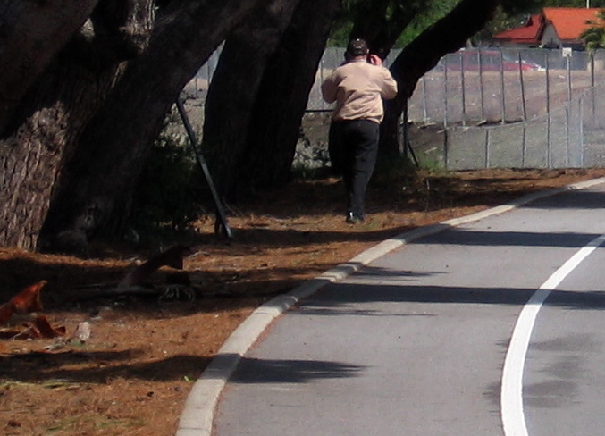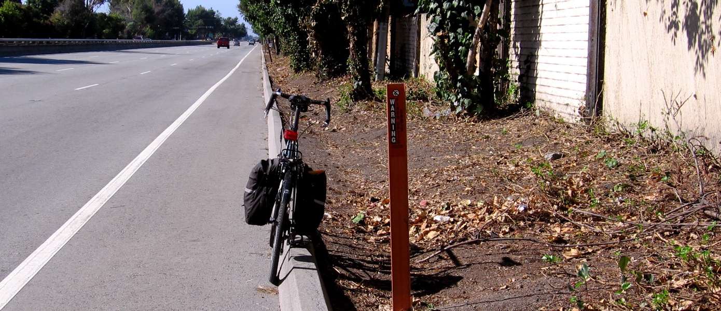
Left photo: Monroe (“Creek Trail”) to Cabrillo (west side)
Right photo: Cabrillo to El Camino (east side, path was created in June in one day)
Below photo: Saratoga to Pruneridge (east side).
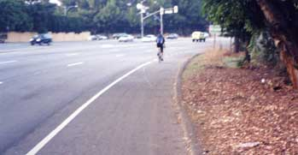
I invite Council members to walk or bicycle with me along San Tomas to see these. Elsewhere, all “obstacles” — brush — can be trimmed in several weeks.
- The 2003 Board Policy (usually called County Expressway Master Plan) added shoulder use:
“Shoulder or path facilities can serve ... for occasional pedestrian use.”
[ Quote 4, the official title is “Comprehensive County Expressway Planning Study Implementation Plan”.
Quote 5 from attached page 93 for the above quote.
Quote 6, the “San Tomas Expressway” section, contains this map:
Quote 7, San Tomas pedestrian map (full size) from page 9.
Also see enlarged Santa Clara portion of the above map with color, enclosed. ]
Our comment: This policy superseded the 1991 policy portion that opposed shoulder use. Staff quoted the 1991 policy opposing shoulder use instead of the 2003 policy that supports shoulder use, but never complied with allowing path use nor with the path creation order, which would have made moot the shoulder use.
- Vehicle Code 21949, new since 2001, states:
“It is the policy of the State of California that safe and convenient pedestrian travel and access ... be provided. It is the intent of the legislature that all levels of government ... work to provide convenient and safe passage for pedestrians on ... all streets and highways, increase levels of walking and pedestrian travel, and reduce pedestrian fatalities and injuries.”
[See attached Quote 8 for the full Vehicle Code section.]
Staffs’ “roadway departure” scare tactic and false statement
At the Council meeting of June 20, 2006, Mr. Yoshino gave a figure of 60% for fatalities that result from “roadway departures”. These facts indicate that this figure was made up:
- To place Mr. Yoshino’s figure into perspective: If 60% of pedestrian fatalities are from his claimed cause, then most pedestrian fatalities in Santa Clara Valley would be from cars jumping the curb and killing pedestrians on sidewalks. The fact is, by far, most pedestrian fatalities are crossing fatalities.
- Mr. Yoshino used a 60% figure for “roadway departures” fatalities. The data we obtained is that less than 1/2 of 1% of total fatalities are pedestrians on shoulders.
- I asked Ms. Sparacino, on July 6, for a copy of the statistical data that was used to obtain Mr. Yoshino’s 60% figure. The City Manager’s office stated that my request was forwarded to Mr. Yoshino, but I have not received a copy to date.
- Mr. Yoshino’s related claim, that curves on San Tomas (45 mph) are a roadway departure risk, needs to be compared with the curves on El Camino (40 mph). The curves under the De la Cruz bridge and near SCU are more than twice as sharp as any curve on San Tomas. Yet, people are allowed to walk on both sides of El Camino there (and elsewhere).
- Mr. Yoshino, furthermore, never gave his 60% figure in his staff report, nor did he reference any data to back up his claim in his staff report. It is nearly impossible to rebut such claims that are made for the first time at a Council meeting, just before a vote, because data and figures have to be searched and printouts made.

Hopefully, staff will not use the same scare tactic against pedestrian use of pedestrian paths, since that would be even more far-fetched.
Truth is paramount for safety
Staff greatly exaggerated roadway departure pedestrian fatalities. Simultaneously, staff assumed that crossing fatality risks are zero (non-existent) when in fact they are the vast majority of pedestrian fatalities. It is important to compare the accident risks of taking the detour route versus the direct route, using real statistics, with the goal of minimizing accident risk for the entire trip. The conclusion is that safety is maximized by minimizing crossings.
Staff’s “high speed traffic” scare tactic
All arterial roads, many with the same or greater speed limit as San Tomas (45 mph), allow pedestrians and bicyclists with two exceptions: San Tomas and Foothill still have walking bans. County staff falsely told Council that Sunnyvale still prohibits and that Capitol Expressway prohibits, when in fact they lost those fights in 1993 (Lawrence in Sunnyvale), 2003 (Central in Sunnyvale) and 1997 (Capitol in San Jose). Pedestrians are allowed the entire length of these roads in all cities, including Santa Clara. Notice the speed limits on these roads:
- North First St. is 45 mph: has bike lanes and sidewalks.
- Trimble Road is 50 mph: has bike lanes and sidewalks.
- Monterey Road is 55 mph: has bike lanes and a sidewalk on one side and a shoulder on the other, both for pedestrians.
- San Tomas is 45 mph: has shoulders and can easily obtain pedestrian paths as already ordered by the Board. The area from the curb to the property-line is typically 12 feet wide (including at intersections), a sidewalk is 5 feet wide, and path is 2 feet wide.
The 1991 Council already rejected these scare tactics
Staff used the same scare tactics against allowing bicycles (1987 to 1991) and pedestrians (1991), but lost both votes. Council voted (May, 1991) to allow bicycles on expressways, and then voted (June, 1991) to allow pedestrians on shoulders along Lawrence between the Lawrence Caltrain station and nearby industry. This was our limited request due to the same scare tactics used today.
Subsequently, all remaining pedestrians prohibited signs on Lawrence in Santa Clara were removed by order of (then) Deputy Director of County Roads, Scotty Bruce, because the needless crossings of the expressway —the result of pedestrians prohibited signs — were much riskier for pedestrians than walking along the expressway on the shoulder. Pedestrian paths were created at intersections where needed. In 1997, these became sidewalks.
More documents show staffs made false statements to Council
- Federal Highway Administration (FHWA) policy: "Paved shoulders have safety and operational advantages for all road users in addition to providing a place for bicyclists and pedestrians to operate." [Source: “Accommodating Bicycle and Pedestrian Travel: A Recommended Approach” by Federal Highway Administration is found on the web by searching for the above title.
Staff’s false statement: Mr. Yoshino’s statement that shoulders are only for “emergency use” is false. Staff also ignored that bicyclists use shoulders, in addition to pedestrians where paths or sidewalks are lacking.

- VTA policy: “This [street] pattern, based on a hierarchy of streets, forces all trips onto the arterial network without regard for their ultimate destination, whether by car, foot, or bicycle.” [Source: "Community Design and Transportation", approved Nov. 7, 2002 by the VTA Board, chapter 4, page 2.]
Staff’s false statement: City Traffic Engineer’s falsely stated: “Pedestrian access along San Tomas is not necessary." [in his staff report to BAC for 3/22/06 meeting]

- Sunnyvale repealed the pedestrian prohibition. The letter from Sunnyvale [see Quote 9] orders County staff to “remove all signs that prohibit pedestrian use along Central Expressway.” (The repeal for Lawrence was in 1993.)
Staff’s false statement: Dan Collen, the invited speaker of Mr. Yoshino, falsely stated that Sunnyvale still prohibits with minor exceptions. There are no exceptions, period.

- Capitol Expressway: The entire length of Capitol allows walkers.
Staff’s false statement: Dan Collen from County Roads statement that pedestrians are still prohibited from Capitol will be proved wrong by photos at the Council meeting, showing people walking on sidewalks and paths. Dan Collen was the staff person that we forced to remove the signs by first requesting a County Counsel legal opinion via the County BPAC and then going to Supervisor Alvarado, showing violations of both law and Board policy. (The City’s ordinance, previously revised at our request, is too legalistic to include here.)

- Liability issue: The City Attorney of the City of Santa Clara answers succinctly to the question “Would there be City liability to allow bicyclists on the expressway?” by the answer “Nominal, if any.” [opinion of Sept. 4, 1987, page 5]. Santa Clara County Counsel agrees in his Legal Opinion dated Feb. 13, 1989. [I include the entire copy of the County Councel’s legal opinion citing the City attorney’s legal opinion in attached Quote 10, since I did not find my original of the City attorney’s opinion.]
Staff’s false statement: Non-legal staff indicated there could be a liability issue without stating anything specific, nor was the City Attorney asked.
Conclusion: If Council opposes shoulder use, consider path use
Please consider these points:
- Paths are preferred over shoulders by walkers and joggers.
- Paths already exist from Monroe (“Creek Trail”) to El Camino, continuing on parallel sidewalk to Benton (total, 1.2 mile).
- Elsewhere, County staff needs to stop using the City’s prohibition as an excuse not to create pedestrian paths, thus violating the 1991 Board order. A mechanism is needed to stop County staff’s excuse, such as a date to allow pedestrians on all of San Tomas. Sixty day notice before removing prohibition signs is plenty to create paths on the remainder of San Tomas. This is considering Road Operations created 1/2 mile of path in one day [as stated by manager Roger Piazza in South Yard.] The remaining distance, from Benton to Stevens Creek, is only 1.7 miles and has paths in portions (including one entire block), so should take no more than 3 days of work to create paths on one side.
- Path and/or shoulder use is the way to eventually obtain sidewalks at no cost to the City. Otherwise, County Roads would not be required to build sidewalks in the future, and the City would have to pay for them. Historically, County Roads’ highway staff avoided spending a penny on sidewalks and pedestrians from their roads budget unless forced to.

We urge adoption of the recommendation of the Bicycle Advisory Committee. This is on the last page, in Quote 11.
For questions, or to walk along the existing pedestrian paths along San Tomas with me, please call me at 221-0694 or email:
[first name] then [“at sign”] then “moderntransit.org”

More San Tomas information, and web links to original documents, is on our web page at: moderntransit.org/st
Sincerely,

Akos Szoboszlay
President

